11.16: (a) Free body diagram of wheelbarrow:

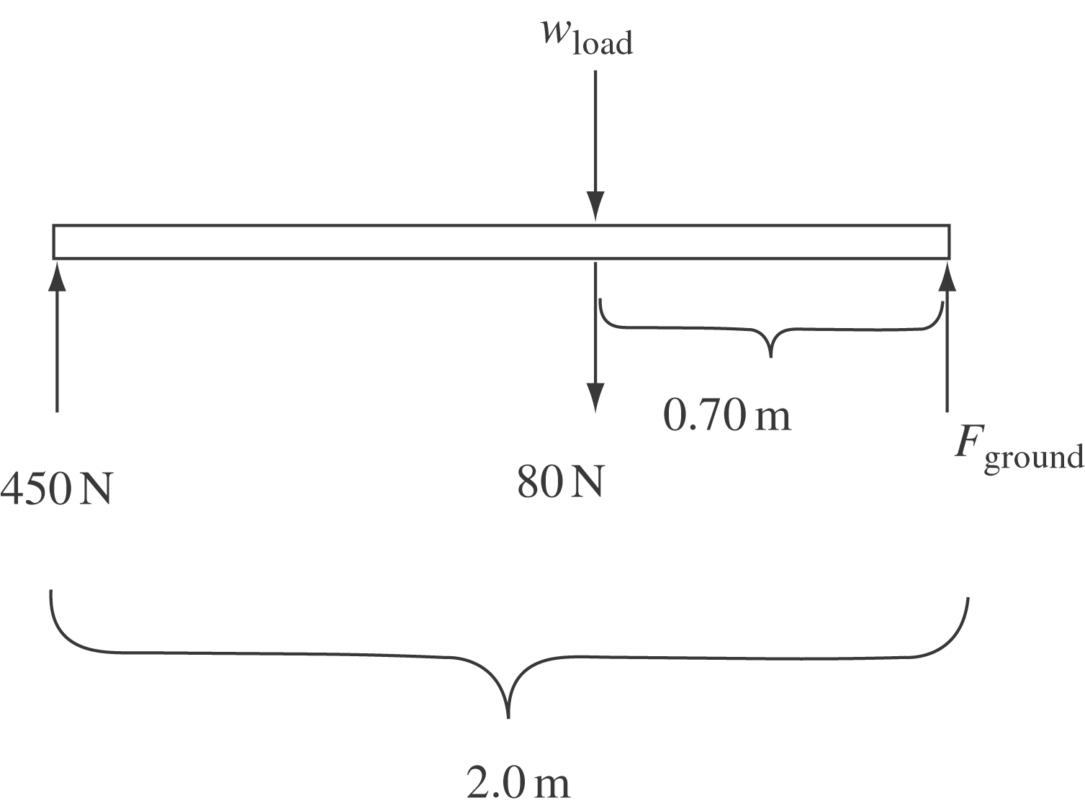

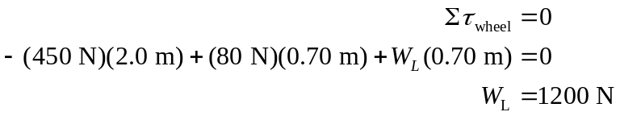

(b) From the ground.

